Technological Institute of the Philippines

938 Aurora Blvd. Cubao, Quezon City

College of Information Technology Education

IT 004 – Web Systems and Technologies

Preliminary Period

|  |  |
| --- | --- |
| Name: RODRIGUEZ, NYX C.  VALDEZ, RONA MAE D. | Date: March 17, 2022 |
| Program / Section: IT21S1 | Instructor: Ms. Roxanne A. Pagaduan |
| Assessment Task: Practice Set No. 1: Designing Web Pages using HTML and CSS | |

**Instructions:**

* Provide screenshots to satisfy the requirements.
* Include your FULLNAME in every screenshot.
* Include a brief description in each screenshot.
* Save your work as **SURNAME1_SURNAME2_PS1.DOC** (Ex. PAGADUAN_ANCHETA_PS1.DOC and .PDF)

**Overview:**

HTML stands for Hyper Text Markup Language. It is a markup language for creating web pages and other information that can be viewed in a web browser. HTML is not a programming language since it uses a markup tags to describe web pages. HTML tags are used to interpret the content of the page in which the browser reads as the HTML documents and displays them as a web page. HTML tags can come in pairs the first tags for the start and the next tags is for end part and surrounded by <angle-brackets>.

HTML element indicates structure in an HTML document. More specifically, it is an SGML element that meets the requirements of one or more of the HTML Document Type Definitions (DTDs). HTML elements generally consist of three parts: a *start tag* marking the beginning of an element, some amount of *content*, and an *end tag*. Elements may represent headings, paragraphs, hypertext links, lists, embedded media, and a variety of other structures.

Cascading Style Sheets or known as CSS is a style sheet that allows the developer or the user to change and modify the looks and style of the webpage. It is one of the important parts of the webpage that allows the creator of the webpage to easily modify their webpage by accessing the CSS file and the html document that will read the CSS file and change the style and the looks of the webpage accordingly. Updating a webpage can be much easier because only the part that the creator needs to modify is the CSS file and not the whole HTML code and with this it avoids errors caused by editing the html code.

**Requirements:**

1. Create a web document that contains the lyrics of your favorite song. Use the following CSS properties: background, padding, margin, border and font. (save your work as PS1-lyrics.html)

Sample Output:

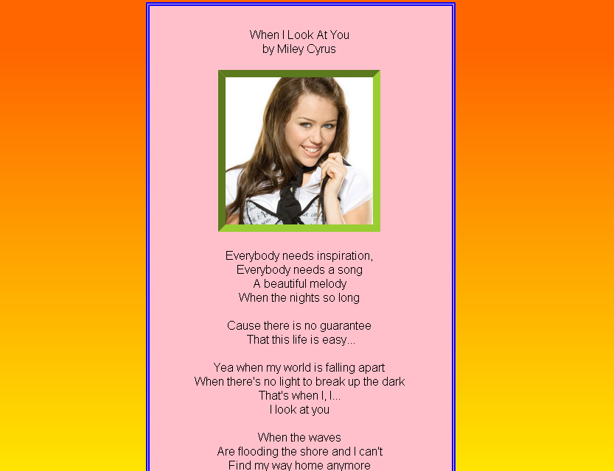

1. Create a homepage for the flower shop using HTML and CSS. *(****note:*** *you can download any related images on the internet)*. Acknowledge references. Save your work as PS1-flowershop.html

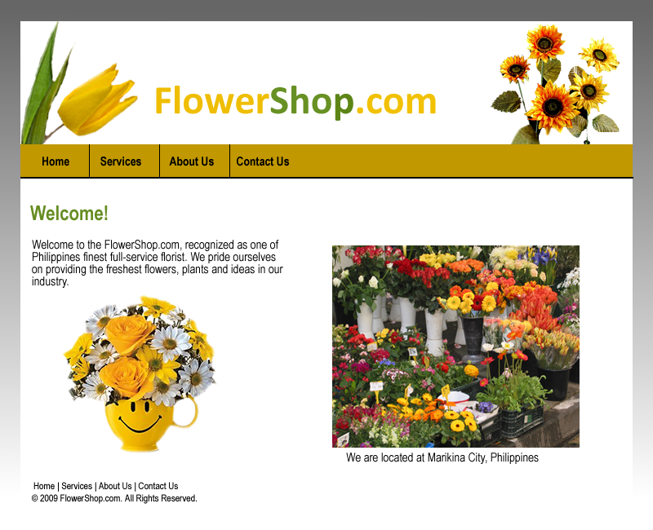

**Assessment Tool:**

This assessment will be graded using the Rubric for Laboratory Performance in Web Systems and Technologies.

**1.)**

**Source Code:**

<!DOCTYPE html>

<html>

<head>

<title>"Simpleng Tao" by Gloc 9</title>

<style type="text/css">

body {

**background-image:**

url(road_2.jpg);

background-size: cover;

background-attachment:

fixed;

}

.content{

background: #F8F8E8;

**border: 5px solid #555;**

width: 40%;

**padding: 30px;**

**margin: 90px auto;**

}

h1{

**font-family: fantasy;**

text-align: center;

font-size: 50px;

line-height: 10px;

color: #2F739F;

}

h2{

font-family: cursive;

text-align: center;

font-size: 20px;

p.solid {border-style: solid;}

}

p{

font-family: fantasy;

text-align: center;

font-size: 23px;

color: black;

}

</style>

</div>

</head>

<body>

<div class="content">

<h1> Simpleng Tao </h1>

<h2> Gloc 9 </h2>

<br>

<p>

<!--lyrics of the song-->

<i>[Verse 1:]</i><br>

Habang tumutunog ang gitara sa 'kin, makinig ka sana<br>

Dumungaw ka sa bintana na parang isang harana<br>

Sa awit na aking i-sinulat ko kagabi<br>

'Wag sanang magmadali at 'wag kang mag-atubili dahil...<br>

<br>

Kahit na wala akong pera<br>

Kahit na butas aking bulsa<br>

Kahit pa maong ko'y kupas na<br>

At kahit na marami d'yang iba<br>

<br>

Ganito man ako (maniwala ka sana sa akin)<br>

Simpleng tao (na ikaw ang lagi kong dalangin)<br>

Ang maipagyayabang ko lang sa 'yo (ay ang)<br>

<br>

<i>[Chorus:]</i><br>

Pag-ibig ko sa 'yo na 'di magbabago<br>

At kahit na anong bagyo, ika'y masusundo<br>

Ganito lang ako (maniwala ka sana sa akin)<br>

Simpleng tao (na ikaw ang lagi kong dalangin)<br>

Na umaasa hanggang ngayon<br>

<br>

Hindi mo namang kailangan ang sagutin<br>

Ang aking hinihiling<br>

Nais na maparating<br>

Na 'di na muli pang dadaloy ang luha<br>

Pupunasan nang kusa<br>

'Di kailanagng manghula<br>

Kahit pamasahe lang ang palagi kong dala<br>

Upang makasama ka<br>

Kapag nakikita ka<br>

Lagi kang aalalayan kahit ano man ang 'yong<br>

Mga ibinubulong<br>

Malalim pa sa balon<br>

Ito lamang ang...<br>

<br>

<i>[Chorus x3]</i><br>

<br>

<i>[Verse 2:]</i><br>

Kay Spider-Man o kay Batman<br>

Kay Superman o Wolverine<br>

Kahit 'di maintindihan<br>

Baka sakaling pansinin<br>

<br>

Ganito lang ako (maniwala ka sana sa akin)<br>

Simpleng tao (na ikaw ang lagi kong dalangin)<br>

Ang maipagyayabang ko lang sa 'yo (ay ang)<br>

<br>

(Pag-ibig) Ko sa 'yo, ito'y totoo<br>

Wala nang iba, ikaw at ako<br>

Lang ang nasa isip at panaginip<br>

'Pag nakikita ka, sasabihin ko'y<br>

<br>

Nawawala, ikaw na nga<br>

Ang dahilan kung bakit nasulat ko ang tulang<br>

Kahit kanino ay aking maipagyayabang<br>

Minamahal kita subalit tanggapin mo sana kahit...<br>

<br>

Ganito lang ako (maniwala ka sana sa akin)<br>

Simpleng tao (na ikaw ang lagi kong dalangin)<br>

Ang maipagyayabang ko lang sa 'yo (ay ang)<br>

<br>

<i>[Chorus:]</i><br>

Pag-ibig ko sa 'yo na 'di magbabago<br>

At kahit na anong bagyo, ika'y masusundo<br>

Ganito lang ako (maniwala ka sana sa akin)<br>

Simpleng tao (na ikaw ang lagi kong dalangin)<br>

Ang maipagyayabang ko lang sa 'yo<br>

<br>

Pag-ibig ko sa 'yo na 'di magbabago<br>

At kahit na anong bagyo, ika'y masusundo<br>

Ganito lang ako (maniwala ka sana sa akin)<br>

Simpleng tao (na ikaw ang lagi kong dalangin)<br>

Na umaasa hanggang ngayon sa pag-ibig mo<br>

<br>

Sa pag-ibig mo<br>

Sa pag-ibig mo<br>

(Maniwala ka sana sa akin)<br>

(Na ikaw ang lagi kong dalangin)<br>

Sa pag-ibig mo<br>

(Maniwala ka sana sa akin)<br>

(Na ikaw ang lagi kong dalangin)<br>

Sa pag-ibig mo<br>

(Maniwala ka sana sa akin)<br>

(Na ikaw ang lagi kong dalangin)<br>

Sa pag-ibig mo<br>

(Maniwala ka sana sa akin)<br>

(Na ikaw ang lagi kong dalangin)

</p>

</div>

</body>

</html>

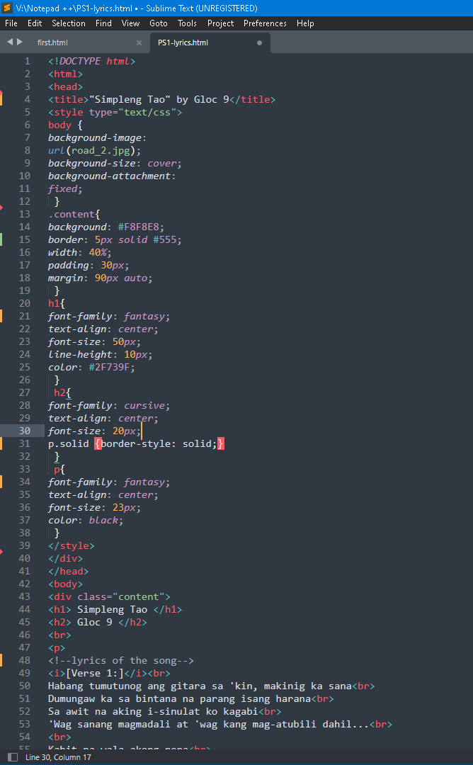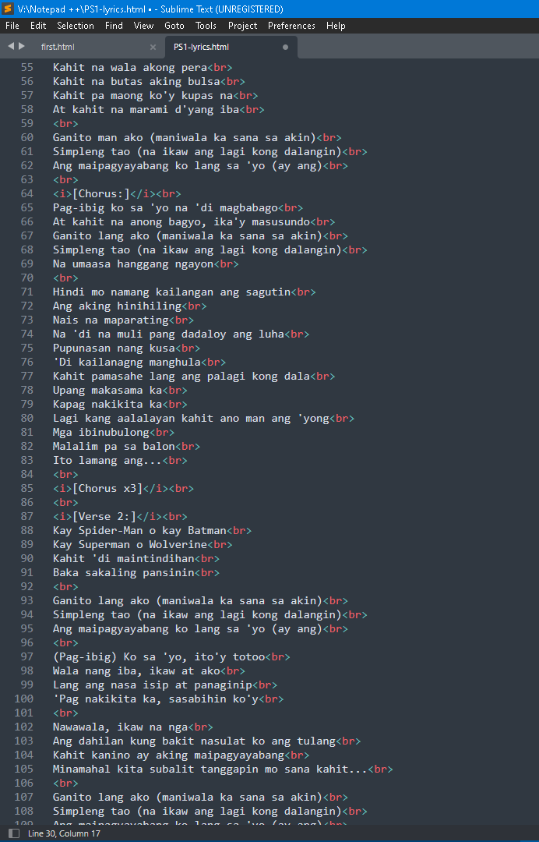

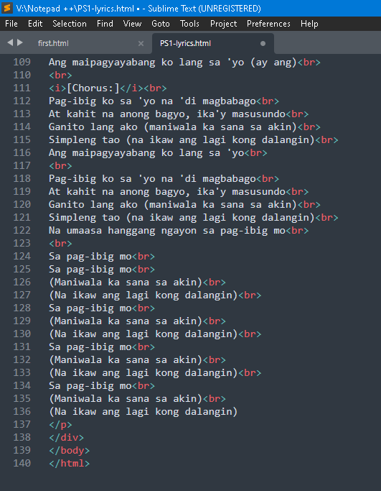

**Sample Output:** (running in the web browser)

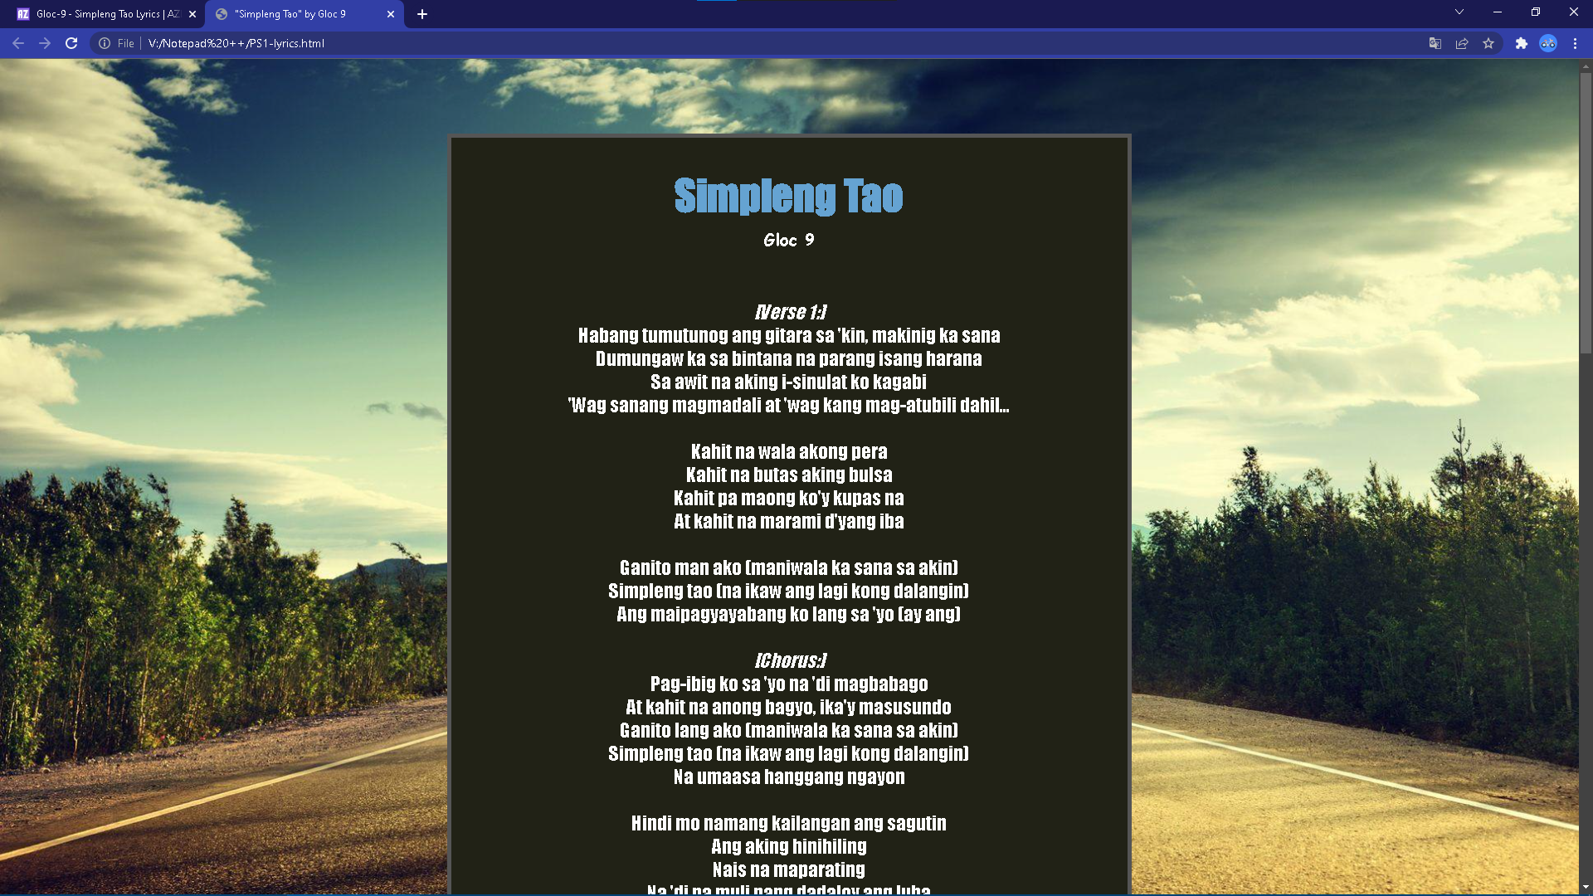

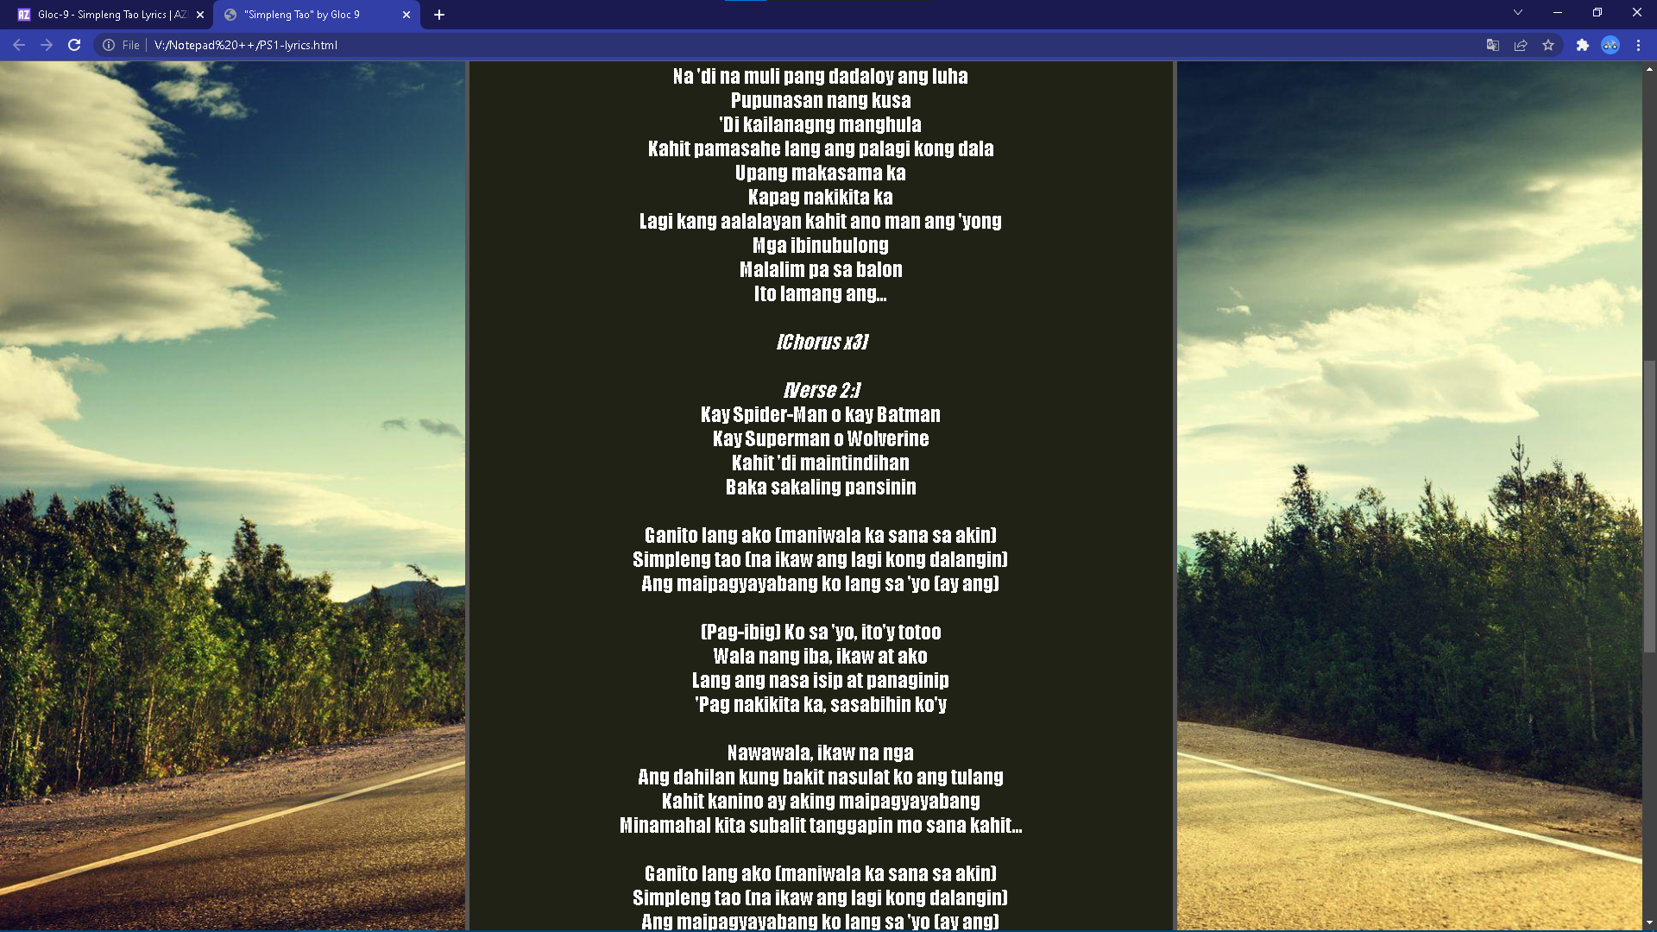

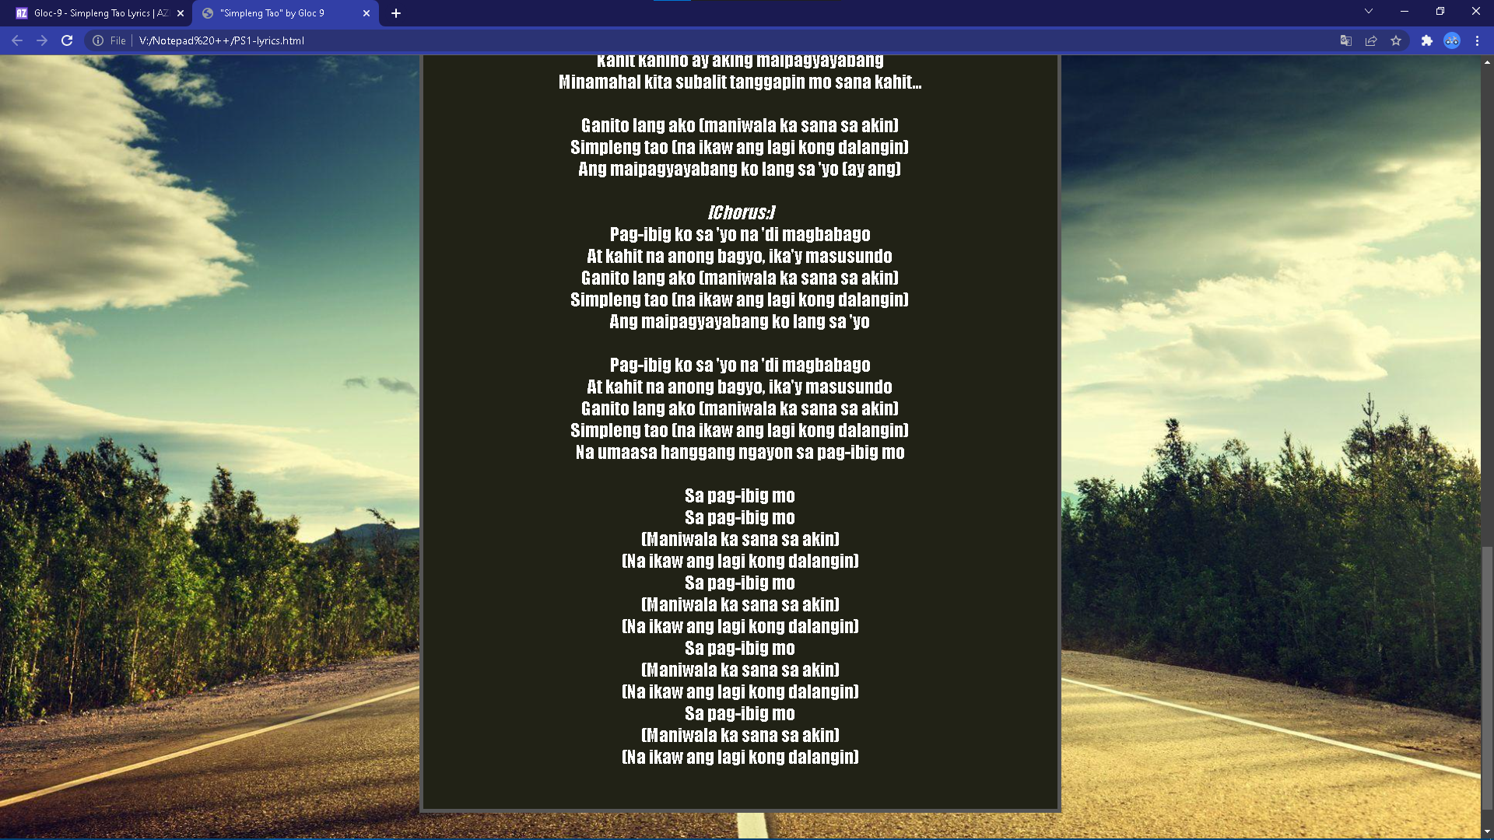

The result is a webpage with the lyrics to the song I chose.

I put in place the necessary components to make the program successful.

**References:**

<https://wallpapercave.com/wp/wp3527436.jpg>

https://www.azlyrics.com/lyrics/gloc9/simplengtao.html

**Source Code:**

<!DOCTYPE html>

<html>

<head>

<Title> Gaia Floral Center </Title>

<style>

body

{

background-image: url("GAIA.png");

background-size: 10%;

background-repeat: no-repeat;

background-position: 1.5% 1.5%;

}

h1

{

font-family: centaur;

font-size:50px;

text-align: center;

}

h2

{

font-family: centaur;

font-size:25px;

text-align: center;

}

h3

{

font-family: centaur;

font-size:30px;

color: green;

}

p

{

font-family: centaur;

font-size:25px;

}

Button

{

background-color: saddlebrown;

border: solid;

border-color: black;

color: white;

padding: 10px 60px;

font-family: timesnewroman;

font-size:20px;

font-weight: bold;

text-align: center;

text-decoration: none;

display: inline-block;

}

img

{

width: 100%;

height: auto;

}

</style>

</head>

<body>

<h1> Gaia </h1>

<h2> Floral Center </h2>

<p style="background-color:olivedrab;">

<button class="button";> Home </button>

<button class="button";> Products </button>

<button class="button";> Services </button>

<button class="button";> About Us </button>

<button class="button";> Contact Us </button>

</p>

<h3> Welcome! </h3>

<p> <img src="Ikebana.png" alt="Ikebana" style="float:right; width:200px; height:400px;">

Pleased to meet you here in our store! <br>

We pride ourselves in offering the most fresh and refined harvests within the plant and floral industry of the Philippines.<br>

<br><br><br>

You can find us at Pasig if you require a more personal experience to our products and services.<br>

</p>

<br><br><br><br><br>

<p>

Home | Products | Services | About us | Contact us <br>

@ 2022 Gaia.ph | All Rights Reserved.

</p>

<img src="ZNGRDN.png" width="1000" height="300" class="center">

</body>

</html>

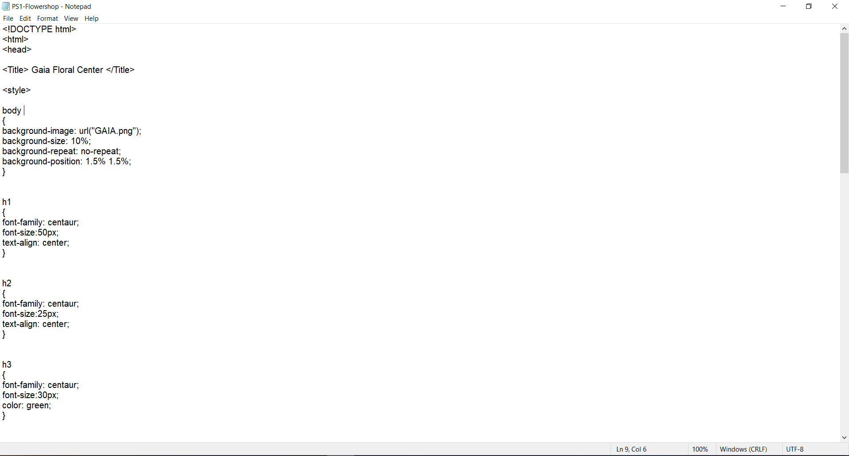

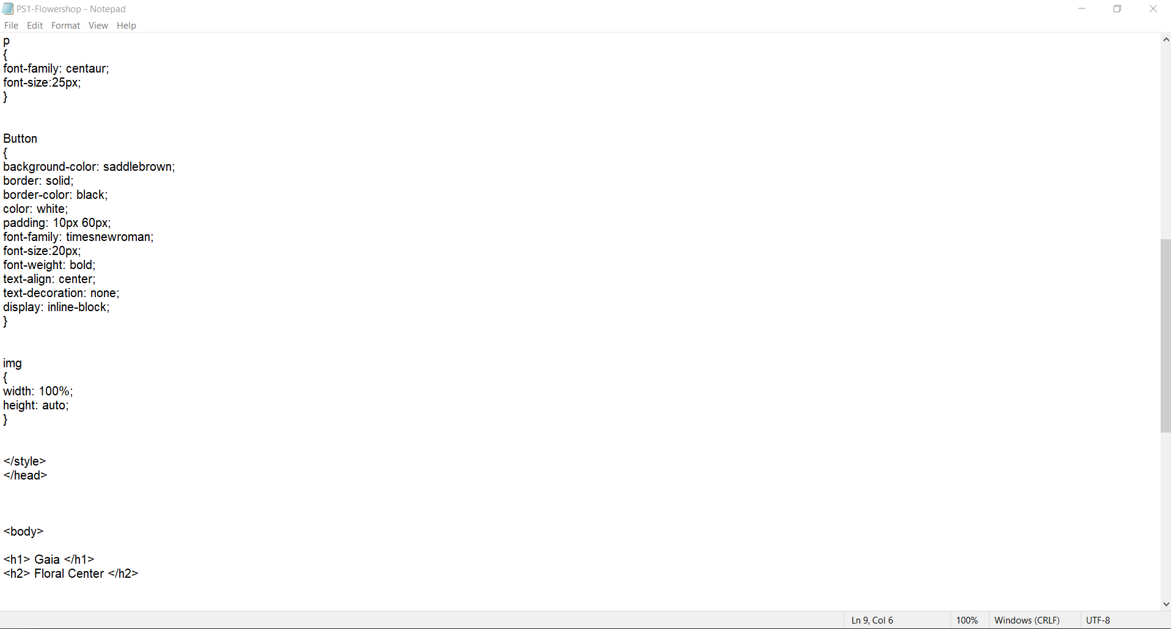

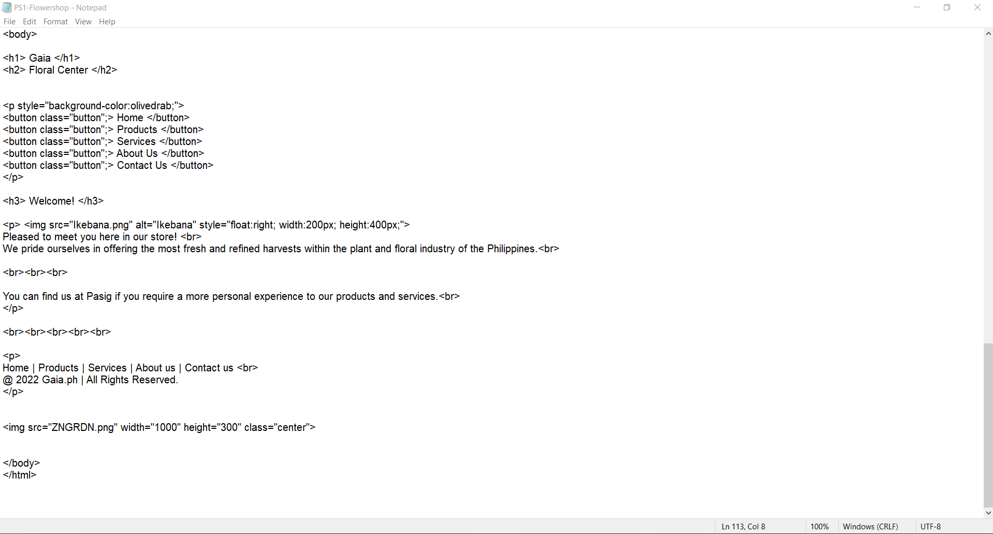

**Sample Output:** (running in the web browser)

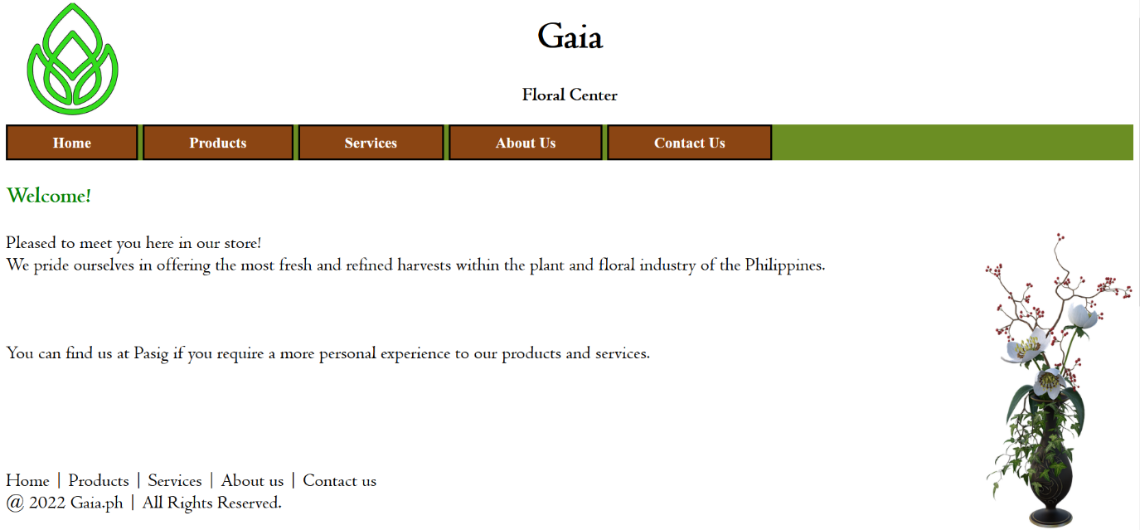

Output handled via Firefox